**Template for Paper Submission to the Thirteenth U.S. National Conference on Earthquake Engineering**

J. Lord[1] and R. Wright[2]

**ABSTRACT**

This template illustrates the format that must be used in preparing papers for theThirteenth U.S. National Conference on Earthquake Engineering. Text and headings should be in 11.5-point type. Included in this template are examples of headings, equation format, references, and other typographical features encountered in technical papers. **Maximum paper length is 4 pages.** A good abstract should be an informative summary of the most important results. It should not be a summary of subjects covered. It should avoid expressions such as “is discussed” and “is described.” It should not include references, figures, or tables. The abstract is of utmost importance because it is the most widely read portion of a manuscript. Abstracts should be no more than 200 words.

# Introduction

The conference proceedings will be compiled directly from the documents submitted by the authors. Therefore, to enhance the overall visual quality of the proceedings, each author should make every effort to comply with the guidelines in the document entitled "13NCEE Paper Formatting Instructions." The purpose of this template is to aid in clarifying those guidelines.

# Author Affiliations

The authors' institutional affiliations and addresses are to be given in single-line form at the bottom of the first page. The last affiliation line should rest on top of an empty line that separates the last author affiliation and the bibliographical reference of the paper. The topmost affiliation line should be directly beneath a two-inch rule. The line should have an email address to contact the author. The example below illustrates the format.

# Bibliographical Reference of the Paper

A bibliographical reference of the paper should be included in the footer of the paper. One line should separate the last author affiliation and the bibliographical reference of the paper. The last line of the bibliographical reference should rest on the bottom margin of the page.

# Margins

Both justified and ragged right margins are acceptable. However, as some word processors justify right margins with awkward character and word spacing, authors should exercise their judgment and select the option that provides the best presentation for their papers.

# Heading 1 Example

The styles for three levels of headings are specified. Heading 1 is shown at the beginning of this section.

A one-line space should precede headings. Do not indent the first line of the first paragraph. Use 0.5 inches of indentation on the first line of the following paragraphs.

## Heading 2 Example

### Heading 3 Example

# Special Features

Among the special features likely to be encountered in a technical paper are equations, figures, tables, and references. This section will show how to deal with these features.

## Equations

Equations should be indented 0.5 inch from the left margin, should have a reference number in parentheses flush with the right margin, and should be preceded and followed by a one-line space. For example,

[M]{Ü} + [K]{U} = {f(t)} (1)

where [M], [K], {Ü}, and {U} are variables in the equation and should be described in the text. Awkward line spacing caused by in-line equations should be avoided. Equations should be referred to in the text as Eq. 1, or as Eq. 2, 3, and 4.

## Figures and Tables

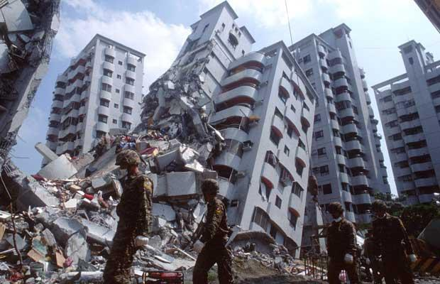

Figure 1. A figure in the text; first letter capitalized, period at end, and indent following lines as shown. If the caption is short, authors should center it under the figure.

As much as possible, Figures and tables should be included in the body of the text directly after they are cited. Placement of tables and figures in the text where reference is made to them is encouraged, as it enhances readability. Each figure should be referred to by number in the text, as in Fig. 3, or as in Figs. 3, 4, and 5. Similarly, tables should be referred to as Table 3, or Tables 3, 4, and 5. All figures and tables **must** be referred to and described in the text. Figure captions should be placed below the figure, and table captions above the table. Leave at least a one-line space between text and captions.

Table 1. Captions of tables; indent following lines with period at end. If the caption is short, authors should center it above the table.

|  |  |  |
| --- | --- | --- |
| **Heading** | **Heading** | |
| Line heading | 111* | 222 |
| Line heading | 33 | 4 |

*Footnote

# References Within Text

References should appear together in the References section (see below) and be listed by number within square brackets in the order in which they appear in the text. All references **must** be cited in the text with numbers inside brackets [1].

# Conclusions

Each paper is expected to state the conclusions of the work concisely. The Conclusions section should discuss the significance and applicability of the work, and not merely restate the abstract. Great care should be exercised to make explicit the limitations or conditions under which the results can be applied.

# Acknowledgments

Acknowledgments should be succinct and used only as necessary.

# Appendix

Appendices should only be used to provide information that would otherwise interrupt the principal focus of the paper or to provide supplemental information to be read by a small portion of the readership. If more than one appendix is necessary, they should be numbered. Appendices should precede the References section. Once complete, save this document as a PDF using the most recent version of Adobe, check the PDF file for appropriate formatting, and upload to the submission site.

# References

## Waters R, Jones JP, Entwistle J. How to make the most out of nothing. *Journal of Universal Something* 2005; 11 (1): 11-111.

## Ambrose J. *Simplified Mechanics and Strength of Materials*. Wiley: New York, 2011.

1. Professor, Dept. of Civil Engineering, University of Somwherehill, Somewhere, XY 12345 (email: XX@abc.edu)
2. Graduate Student Researcher, Dept. of Civil Engineering, University of Somwherehill, Somewhere, XY 12345